- What is an API ?
  - API stands for Application programming interface
  - An API enables data transfer/communication across multiple modules in an enterprise application, using data descriptive languages such as text, html, xml, json, yaml etc
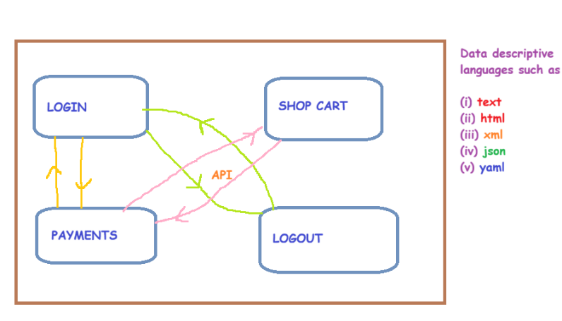
- What is Client & Server architecture ?
  - Client: It is an application/device that submits a request to the server
    - eg. Browser, Postman
  - Server: It is an application/device that receives client requests to analyze them + process them + submit response to the client
    - eg. Apache Tomcat, Nginx, Microsoft IIS, IBM Websphere, Glassfish
    - eg. AWS, Azure, GCP, Ctrl+S
  - Protocol: It is a set of rules & regulations that abides the client & server on how to communicate with each other
    - eg. HTTP, HTTPS, FTP, MQTT, SMTP, POP3, IMAP, SQL, JDBC, GRAPH-QL, LDAP etc
    - HTTP
      - Hypertext transfer protocol
      - Unsecured protocol
      - The data is transferred in plain text format between client & server
    - HTTPS
      - Hypertext transfer protocol with security
      - Secured protocol
      - The data is transferred in encrypted format between client & server
      - HTTP + SSL = HTTPS [outdated]
      - HTTP + TLS = HTTPS [latest]
  - HTTP Methods: It describes ‘the type of client request’ being sent to the server
    - eg. GET, POST, PUT, PATCH, DELETE
    - GET: It is used by client to retrieve/read/fetch the existing data from the server/database
      - eg. browsing the web pages/messages/emails, file download
    - POST: It is used by client to create new data on the server/database
      - eg. user registration/sign-up, sending emails/messages, file upload
    - PUT: It is used by client to update/modify/replace the existing data (full or partial) on the server/database
      - eg. profile picture updates, updating the already created order, change password
    - PATCH: It is used by client to update/modify/replace the existing data (partial) on the server/database
      - eg. profile picture updates, updating the already created order, change password
    - DELETE: It is used by client to delete the existing data on the server/database
      - eg. deleting emails/messages, deactivating social media accounts
  - REQUEST HEADERS: It is the additional meta-data sent by client along with request, to the server
    - Connection: keep-alive ; close
    - User-Agent: who am I [OS, browser etc]
    - Authorization: user identity/credentials
    - Content-Type: format of client request body eg. json, xml, html, text
    - Accept: format of server response eg. json, xml, html, text
    - Accept-Lang: language of server response eg. EN-US, EN-GB, EN-IND, HINDI, CHINESE
  - RESPONSE HEADERS: It is the additional meta-data sent by server along with response, to the client
    - Connection: keep-alive ; close
    - Content-Type: format of server response body eg. json, xml, html, text
    - Server:
    - Date:
    - Cookies:
  - RESPONSE CODE: It is a 3 digit status code sent by server to the client, to reveal the status of client request
    - Range: {100-599}
    - 100-199 = 1xx = Informational responses
    - 200-299 = 2xx = Successful responses
    - 300-399 = 3xx = Re-directional responses
    - 400-499 = 4xx = Client-side errors
    - 500-599 = 5xx = Server-side errors
COMMON RESPONSE CODES:
- 200 OK
- 201 Created
- 202 Accepted
- 204 No Content
- 400 Bad request
- 401 Unauthorized
- 403 Forbidden
- 404 Not found
- 500 Internal server error
- 503 Service unavailable
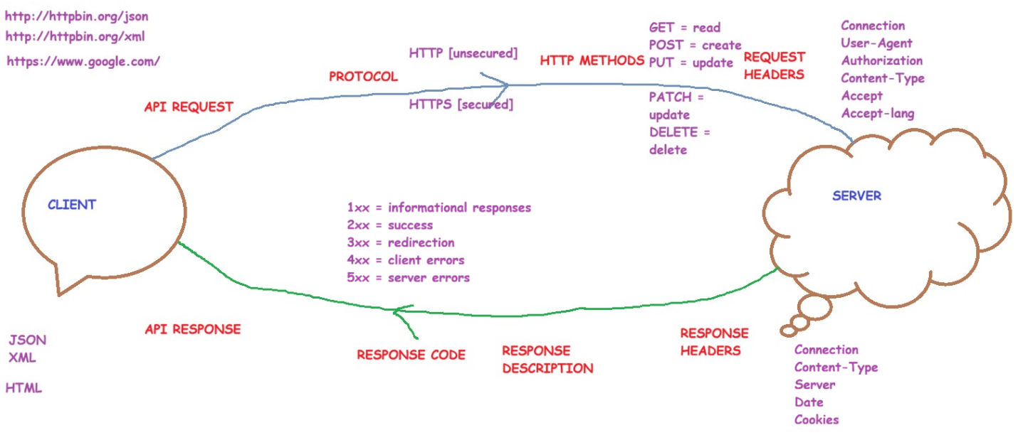
- What is 3-layer architecture model
  - Front-end-system
    - Here, APIs are consumed
    - FE system is also called as client or consumer
  - Back-end-system
    - Here, APIs are developed & shared with other systems
    - BE system is also called as producer
  - Server-side-system
    - All data level validations received in the BE API request are validated here
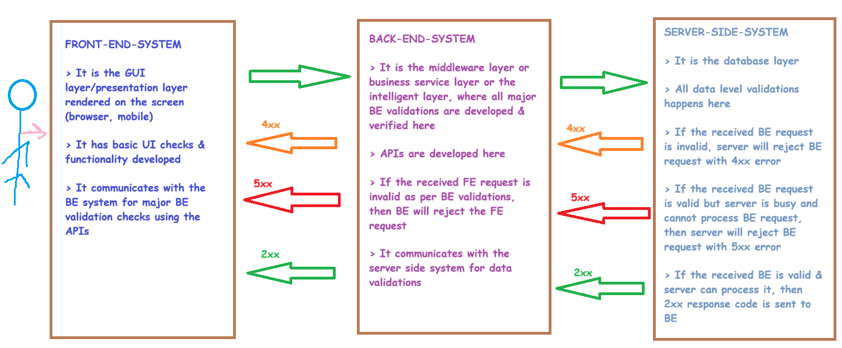
- Evolution of APIs technology
  - XML-RPC-APIs
    - Remote procedure calls
    - Content-Type = XML
    - 100% outdated
  - SOAP APIs
    - Simple object access protocol
    - Content-Type = XML
    - HTTP method allowed = POST
    - 90% outdated ; 10% usage
    - Tools used to test SOAP APIs: Postman, Rest-Assured, SOAP UI, Insomnia, Katalon, k6 etc
  - REST APIs
    - Representational state transfer
    - Content-Type = any format is allowed such as json, xml, html, text, yaml etc
    - HTTP methods allowed = all methods are allowed such as get, post, put, patch, delete etc
    - Google is the founder for REST APIs technology
    - 100% usage
    - Tools used to test REST APIs: Postman, Rest-Assured, SOAP UI, Insomnia, Katalon, k6 etc
  - GRAPH-QL-APIs
    - Query language-based APIs
    - It is an advanced version of REST APIs
    - Facebook is the founder for Graph-QL APIs technology
    - 40% usage
    - Tools used to test Graph-QL APIs: Postman, Rest-Assured etc

REST API vs REST Assured (testing tool)
Rest API === Rest Assured [incorrect]
Rest API can be tested only with Rest Assured tool [incorrect]
Postman vs Rest Assured [both are testing tools]
- Classification of APIs
  - Public APIs
    - These APIs are accessible to all users on the internet
    - eg. https://httpbin.org/json
  - Private APIs
    - These APIs are accessible to limited users on the internet
  - Secured APIs
    - These APIs expect the user to prove user identity by entering user credentials such as UN+PWD, API-token, API-key etc
    - eg. http://httpbin.org/basic-auth/user/passwd
  - Unsecured APIs
    - These APIs do not expect the user to prove user identity
    - eg. https://httpbin.org/xml

 | PUBLIC API | PRIVATE API | SECURED API | UNSECURED API
REST API | ✓ | ✓ | ✓ | ✓
SOAP API | ✓ | ✓ | ✓ | ✓
GRAPH-QL API | ✓ | ✓ | ✓ | ✓

Q1: Are we using REST APIs or SOAP APIs or Graph-QL APIs in our project ?
Q2: Are we classifying our developed APIs as public or private ?
Q3: Are we classifying our developed APIs as secured or unsecured ?

- API SYNTAX
httpMethod – protocol – baseURL – endPoint – queryParameters – requestBody/payload – requestHeaders – authorization
- httpMethod = get, post, put, patch, delete
- protocol = http, https
- baseURL = it is the domain name or host name or server IP address
  - eg. www.google.com www.amazon.in
- endPoint/pathParameters = it is the page/path accessed on the baseURL and it always starts with a forward slash /
  - eg. www.google.com/news www.amazon.in/mobiles/android
- queryParameters = it is the search/filter criteria applied on an endPoint in the baseURL and it always starts with a question mark ?
  - eg. www.google.com/news?q=goldrate www.amazon.in/mobiles/android?k=samsung&k=8GBRAM
- requestBody = it is the client input data being supplied along with API request and it is mandatory for POST API, PUT API, PATCH API and optional for GET API, DELTE API. It is also referred to as payload and mostly it will be in JSON or XML format.
- requestHeaders = it is the additional meta-data supplied by the client to the server, along with API request
  - eg. Connection, User-Agent, Content-Type, Accept, Accept-Lang, Authorization etc
- authorization = it is the added layer of security in the API where the user provides user identity in the API request such as UN+PWD or API-token or API-key etc

- Examples of REST APIs on the internet:
  - https://reqres.in/
  - https://gorest.co.in/
- Examples of SOAP APIs on the internet:
  - http://www.dneonline.com/calculator.asmx?op=Add
  - http://webservices.oorsprong.org/websamples.countryinfo/CountryInfoService.wso?WSDL
- Examples of GRAPH-QL APIs on the internet:
  - https://countries.trevorblades.com/

- API TESTING TECHNIQUES
    - Positive Testing/Smoke Testing
      - Response code testing
      - Response time testing
      - Response body testing
      - Response headers testing
      - Interoperability testing
      - Data driven automation testing
      - Performance testing
      - API chaining automation testing
      - E2E user journey automation testing
      - Continous automation testing
      - Newman based CLI testing
    - Negative Testing/Regression Testing
      - Unsupported HTTP methods testing
      - Broken endPoints testing
      - Payload tampering testing
- REUSABLE API TEST PLAN
- REUSABLE API TEST CASES
- POSTMAN-INTRODUCTION & INSTALLATION
  - It is used by Developers, QA & DevOps engineers to develop, test & deploy the APIs https://postman.com/
  - It is available as open-source/free as well as licensed software https://www.postman.com/pricing/
  - Postman can be accessed via the desktop application (recommended) and online web application (beta version)
    - https://www.postman.com/downloads/
    - https://identity.getpostman.com/signup?
  - Download the Postman tool > Install the Postman tool > Sign up as a new user > Sign in as an existing user
  - Workspaces :
    - It is the project repository in Postman tool
    - 5 types of workspaces are supported by Postman
      - Personal workspace : You are the only person who can contribute to work on this workspace
      - Team workspace : You & your team are the contributors who can work on this team workspace
      - Public workspace : All logged in Postman users can search & find the public workspaces and they will have read only access to public workspaces
      - Partner workspace
      - Private workspace
    - Actions that can be performed on workspaces:
      - Create a workspace
      - Invite a person to the workspace
      - Rename the workspace
      - Convert the workspace category
      - Delete the workspace
- PROJECT#1
  - API documentation URL: https://gorest.co.in/ OR https://gorest.co.in/rest-console
  - APIs technology used: REST APIs
  - Classification of APIs: Public APIs + Secured APIs
  - Algorithm used to secure APIs: Bearer access token
  - HTTP methods used: GET, POST, PUT, DELETE
  - Description of the APIs developed:
    - LIST USERS API: This API uses GET http method & is used to retrieve all the existing users from the database
    - CREATE USER API: This API uses POST http method & is used to create a new user in the database
    - UPDATE USER API: This API uses PUT http method & is used to update an existing user in the database
    - DELETE USER API: This API uses DELETE http method & is used to delete an existing user in the database
  - Business rules to test APIs:
    - Gender = {male, female}
    - Status = {active, inactive}
    - Email = valid format & unique email
  - Capture the APIs from https://gorest.co.in/rest-console to understand the below API request details:
    - API name
    - API HTTP method
    - API URL
    - API request body/payload
    - API request headers
    - API auth
  - Hit on SEND button on https://gorest.co.in/rest-console after configuring the API request to understand the below API response details:
    - Response code
    - Response time
    - Response body
    - Response headers
  - Expected results:
    - LIST USERS API:
      - Response code: 200 OK
      - Response time < 2 seconds
      - Response body = JSON format
      - Response body should contain fields such as id, name, email, gender, status in the received JSON response
    - CREATE USER API:
      - Response code: 201 Created
      - Response time < 2.5 seconds
      - Response body = JSON format
      - Response body should contain fields such as id, name, email, gender, status in the received JSON response
      - Gender={male, female}
      - Status={active, inactive}
    - UPDATE USER API:
      - Response code: 200 OK
      - Response time < 2.5 seconds
      - Response body = JSON format
      - Response body should contain fields such as id, name, email, gender, status in the received JSON response
      - Gender={male, female}
      - Status={active, inactive}
    - DELETE USER API:
      - Response code: 204 No Content
      - Response time < 2 seconds
      - Response body = empty
- Let us automate project#1 in Postman tool
  - Launch Postman > Sign in > Create a workspace > Create a collection > Create a folder ‘Positive Testing’ > Add the required API requests > Configure each API as per API documentation received from the developer > Save the API request > Hit on SEND button to receive API response > Validate the response code, response time, response body, response headers
  - Write the assertions/java-scripts to validate the response code, response time, response body, response headers etc
  - Run the collection to validate all the APIs response and generate test report in .json format
  - The historical API runs or collection runs are stored in 2 locations:
    - Collection > Runs
    - History
  - To share collection with another user, click on … next to collection > click on Share > enter the email id to share the collection with another user OR generate an invite link & share with another user
  - Collections deleted can be restored from Trash
  - To download/export the collection, click on … next to collection > click on more > click on export collection > click on Export JSON > choose a location on your PC > click on Save button
  - To import the downloaded collection (.json file), click on … > click on import > click on select files > select the collection.json file > click on import > the postman collection will now be imported successfully to the postman tool
- Interoperability testing
    - It is a compatibility test to verify if the API works on the supported OS & browser version(s) & returns 2xx success response code
    - It is achieved by customizing the ‘User-Agent’ request header
    - User Agents can be found here : https://www.whatismybrowser.com/guides/the-latest-user-agent/
    - For eg, below are the supported OS & browser versions:
      - Windows OS + Edge browser
      - Mac OS + Safari browser
      - Linux OS + Firefox browser
      - Android OS + Chrome browser
- Data driven automation testing-Using CSV
    - It is the process of testing the given API with multiple sets of test data which is supplied via an external data file such as .csv
    - Open an .xls file > Write the required test data along with column name > Save this file as .csv on the computer
    - Use the column name as variable in the User-Agent request header in the Postman tool for the API to be tested
    - Variable syntax: {{variableName}}
    - Run the entire folder > supply .csv test data > Run the folder > Analyze the test results > Export the test result
- Data driven automation testing-Using Postman functions
    - Using Postman functions, we can generate dynamic/random test data during the test execution
    - Postman uses java-script faker library to generate random/dynamic test data
    - https://learning.postman.com/docs/tests-and-scripts/write-scripts/variables-list
- API chaining automation testing
    - It is the process of extracting the response from an API and supplying it as request to another dependent API
    - Follow the below steps to achieve API chaining automation testing:
      - Extract the entire response body & store it in a local variable
      - Extract the required field(s) from the response body & store it in a local variable
      - Convert the local variables to global variables
      - Refer the global variables in other dependent APIs
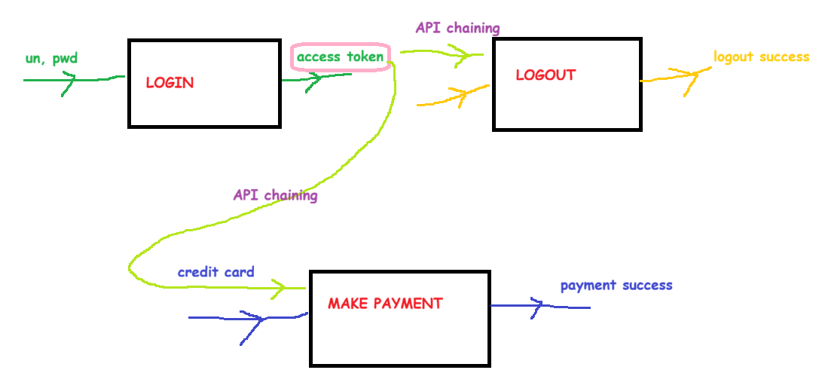
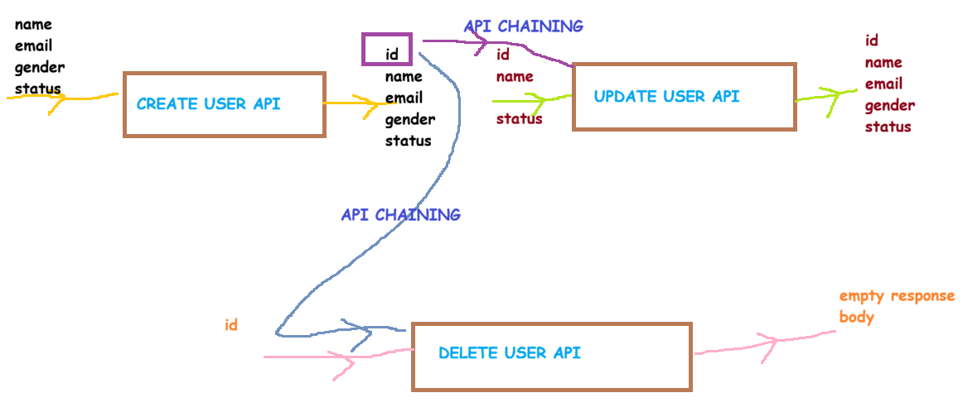
Let us conduct API chaining automation for the below API workflows:
- CREATE USER API > EXTRACT ID > UPDATE USER API
- CREATE USER API > EXTRACT ID > DELETE USER API

- E2E user journey automation testing
    - Create a user > Verify if user is created > Update the user > Verify if user is updated
    - Create a user > Verify if user is created > Delete the user > Verify if user is deleted
    - Create a user > Verify if user is created > Update the user > Verify if user is updated > Delete the user > Verify if user is deleted
- Negative testing
    - Unsupported HTTP methods testing: It is conducted by testing an API with an invalid HTTP method and the expected response code is 405 Unsupported HTTP method
    - Broken endPoints testing: It is conducted by testing an API with an invalid endPoint and the expected response code is 4xx client-side error
    - Payload tampering testing: It is conducted by testing an API with an invalid payload such as invalid data type, invalid data length, invalid data field, missing data field(s) and the expected response code is 4xx client-side error
- Continous testing using Postman monitors
    - Postman auto-executes the collection at the specified time when the collection is monitored using Postman monitors or schedulers in collection runner
    - Postman monitors or schedulers always run on the Postman AWS servers and hence, even if Postman is closed or your computer is shutdown, the monitors or schedulers will still run as per the scheduled time
- Integration of Postman with AI
    - We can use ‘Ask AI’ feature in Postman to generate
      - Create automation tests i.e., assertions/java-scripts
Sample prompt:
Execute the API tests in this collection 'AI GENERATED ASSERTIONS' to understand the server response. Based on the server response received, write java-scripts to assert response code, response time, response body content, response body schema, if response body is in JSON format and any other required validations.
      - Create a collection based on the cURL API documentation shared by developer
- GET API
curl -X GET https://jsonplaceholder.typicode.com/posts/1

- POST API
curl -X POST https://jsonplaceholder.typicode.com/posts \
-H "Content-Type: application/json" \
-d '{"title": "foo", "body": "bar", "userId": 1}'

- PUT API
curl -X PUT https://jsonplaceholder.typicode.com/posts/1 \
-H "Content-Type: application/json" \
-d '{"id": 1, "title": "updated title", "body": "updated body", "userId": 1}'

- PATCH API
curl -X PATCH https://jsonplaceholder.typicode.com/posts/1 \
-H "Content-Type: application/json" \
-d '{"title": "just changing the title"}'

- DELETE API
curl -X DELETE https://jsonplaceholder.typicode.com/posts/1
Sample prompt:
Create a new Postman collection for the below cURL format based REST APIs and create 2 folders to organize the positive testing & negative testing. Also, write java-scripts/assertions after analyzing the server response received for each REST API.

• GET API
curl -X GET https://jsonplaceholder.typicode.com/posts/1

• POST API
curl -X POST https://jsonplaceholder.typicode.com/posts \
-H "Content-Type: application/json" \
-d '{"title": "foo", "body": "bar", "userId": 1}'

• PUT API
curl -X PUT https://jsonplaceholder.typicode.com/posts/1 \
-H "Content-Type: application/json" \
-d '{"id": 1, "title": "updated title", "body": "updated body", "userId": 1}'

• PATCH API
curl -X PATCH https://jsonplaceholder.typicode.com/posts/1 \
-H "Content-Type: application/json" \
-d '{"title": "just changing the title"}'

• DELETE API
curl -X DELETE https://jsonplaceholder.typicode.com/posts/1

      - Create a collection based on the Swagger API documentation shared by developer
https://petstore.swagger.io/
Sample prompt:
Create a new Postman collection for the below Swagger format based REST APIs and create 2 folders to organize the test cases into positive testing & negative testing. Also, write java-scripts/assertions after analyzing the server response received for each REST API.
https://petstore.swagger.io/v2/swagger.json
      - Create a collection based on the Front-end application i.e., website functionality when API documentation is unavailable to the QA team
https://blazedemo.com/login
https://blazedemo.com/register
https://blazedemo.com/password/reset
Sample prompt:
Create a new Postman collection for the below website functionalities which are internally using REST APIs and create 2 folders to organize the test cases into positive testing & negative testing. Also, write java-scripts/assertions after analyzing the server response received for each REST API.
https://blazedemo.com/login
https://blazedemo.com/register
https://blazedemo.com/password/reset
- Integration of Postman with GitHub using Git
    - Git & GitHub are not same
    - Git is an open-source version control mgmt software
    - GitHub is from Microsoft
    - GitHub is used to back-up the automation code which is version controlled by Git
    - Download & Install Git from https://git-scm.com/install/windows
    - Verify if Git is successfully installed by opening command prompt & run the command git --version
    - To initialize Git at the API project folder, open command prompt at the project folder location & type git init
    - To know the status of git tracking, type git status
    - To track all the untracked files/folders, type git add .
    - To commit all the tracked files/folders, type git commit -m “reason-for-commit”
    - To push the tracked+committed files/folders by Git into GitHub, follow below steps:
      - Create your free GitHub account at https://github.com/signup?
      - Login to GitHub account at https://github.com/login?
      - Create a repository (project) in GitHub
      - Git refers to the default branch as master
      - GitHub refers to the default branch as main
      - Now, come back to command prompt & change the branch name from master to main by executing git branch -M main
      - To push the git tracked main branch data into GitHub main branch, run the command git push -u GitHubURL main
      - Refresh the GitHub repo page to ensure the Git tracked project data is now available as a backup copy
- Integration of Postman with Newman
    - Newman is an add-on from Postman to run the collections & generate test reports in various formats such as cli, json, junit, csv, html-extra
    - Postman collections can be executed via CI/CD/CT pipelines in Jenkins using Newman commands
    - Newman runs Postman collections from cli mode (command line interface)
    - Pre-requisites for Newman installation:
      - Install NodeJS https://nodejs.org/en/download
      - Install Newman
        - npm install -g newman
      - Install HTML-Extra plugin
        - npm install -g newman-reporter-htmlextra
    - To run Postman collections using Newman & generate test reports, the commands are
- newman run postmanCollectionPath -r cli
- newman run postmanCollectionPath -r json
- newman run postmanCollectionPath -r junit
- newman run postmanCollectionPath -r htmlextra

- Integration of Postman with Jenkins for CI/CD/CT
    - CI = Continous integration
      - CI is a process where code written by various developers is integrated to generate a new build for further testing activities
    - CD = Continous deployment & delivery
      - CD is a process where the new build generated by CI process, is auto deployed in the next environment
    - CT = Continous testing
      - CT is a process where the build deployed during CD process in the testing environment is auto tested using automation code
    - Jenkins is a CI/CD/CT tool
    - Jenkins is a server-side application built using Java
    - Pre-req: Java JDK v21, 25
    - Java JDK v21 is available for download & installation at https://www.oracle.com/java/technologies/javase/jdk21-archive-downloads.html
    - Download Jenkins (jenkins.war) from https://www.jenkins.io/download/

- Variables usage in Postman
- PROJECT#2 – SOAP APIs
- PROJECT#3: AUTH BASED REST APIs
- POSTMAN IMPORT FEATURE
- POSTMAN SETTINGS
- POSTMAN LEARNING CENTER & TROUBLESHOOTING

